**How to configure Amazon Neptune**

1. Setup your accounton <https://aws.amazon.com/neptune/>
   * Info: it requires card for activation
2. On Amazon Neptune page > Create database
   * Use default settings and change the next things:

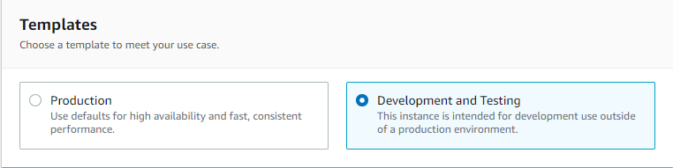

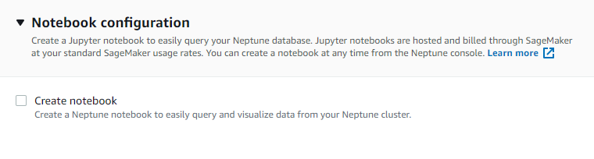

* It might take 15 minutes to finish the generation

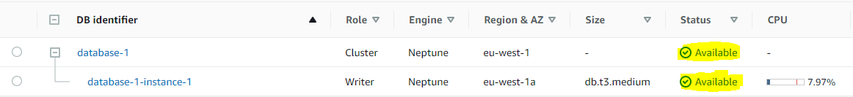

1. Change the permission for the security group from the Writer component

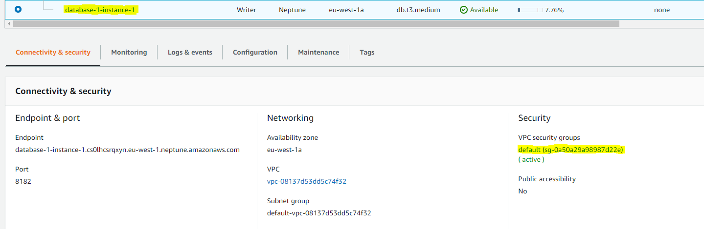

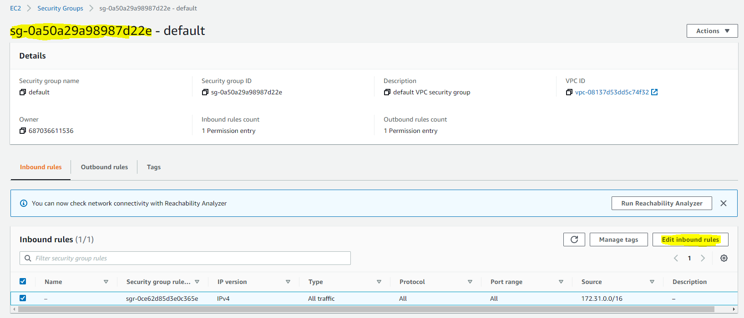

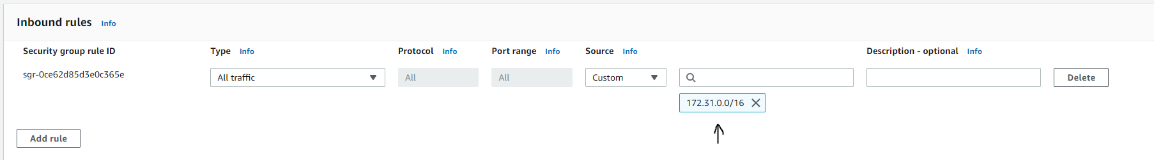

* We make this change to be able to load from s3 bucket

1. Create an Identity and Access Management Policy and Role

* Navigate to IAM Console > Create policy > Choose JSON tab
  + {
  + "Version": "2012-10-17",
  + "Statement": [
  + {
  + "Effect": "Allow",
  + "Action": ["s3:ListBucket"],
  + "Resource": ["arn:aws:s3:::bucket-name"]},
  + {
  + "Effect": "Allow",
  + "Action": ["s3:GetObject"],
  + "Resource": ["arn:aws:s3:::bucket-name/*"]}]}
* Change bucket-name with your s3 server name
* When creating Role, detach all policy and attach the new one created recently
* At the trust relationship:
  + {
  + "Version": "2012-10-17",
  + "Statement": [
  + {
  + "Sid": "",
  + "Effect": "Allow",
  + "Principal": {
  + "Service": [
  + "preprod.rds.amazonaws.com",
  + "rds.amazonaws.com"]},
  + "Action": "sts:AssumeRole"
  + }]}

1. Create an endpoint

* VIRTUAL PRIVATE CLOUD > Endpoints > Create endpoint
* We use this to communicate between S3 Bucket and Neptune DB
* Use default settings and change Service Name like in the picture

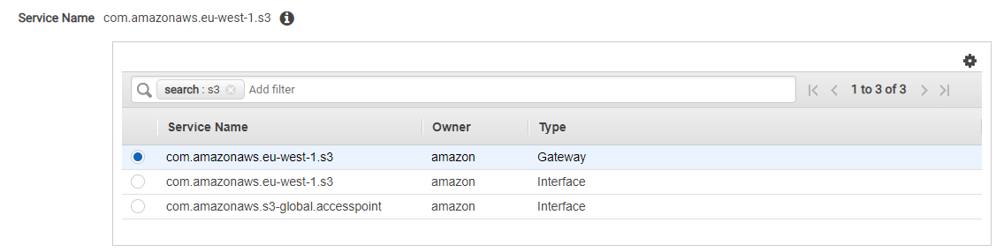

1. Create a S3 Bucket and upload your files
2. Create a Notebook from Neptune > Create a new Python3 file then execute the next commands:

* %status – make sure the status is healthy
* %load

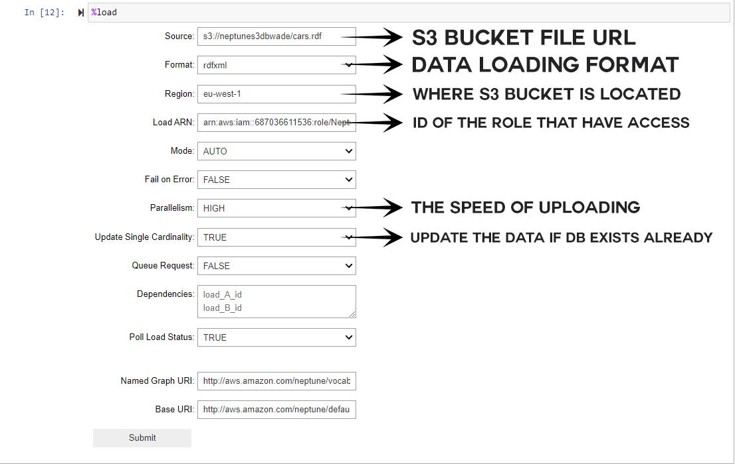

1. Submit and enjoy
2. Example of SPARQL query



Additional information can be found here:

* <https://manualzz.com/doc/o/uy531/amazon-neptune---user-guide---aws-documentation-neptune-loader-api-reference>
* <https://docs.aws.amazon.com/neptune/latest/userguide/bulk-load-tutorial-IAM.html>